Hooli XYZ

**Sprint 2 Report**

**Sprint Period:** 21/03/2016 – 11/04/2016

**Members:**

Connor Beardsmore – 15504319

Brendan Lally – 18407220

Adam Brown – 18338993

Jordan Chou – 18348691

Edward Lim - 18339145

**Table of Contents:**

1. Sprint Planning
2. SCRUM Meetings
3. Sprint Review
4. Sprint Retrospective

Appendix A: CSV of all user stories

Appendix B: Screenshots of Functionality

**1. Sprint Planning**

**User Stories:**

The following user stories were selected for completion in Sprint 2.

|  |  |  |  |
| --- | --- | --- | --- |
| Number: | User Story: | Area: | Effort Points: |
|  |  |  |  |
|  |  |  |  |
|  |  |  |  |
|  |  |  |  |
|  |  |  |  |
|  |  |  |  |
|  |  |  |  |

**Sprint Goal:**

**Task Breakdown:**

**Task Distribution:**

|  |  |
| --- | --- |
| Members: | Area of Focus: |
| Connor |  |
| Jordan, Adam |  |
| Brendan, Edward |  |

**Effort Estimation:**

**2. SCRUM Meeting**

**Meeting #1 : 28/03/16**

**Attendance : Connor, Jordan, Adam, Brendan, Edward**

|  |  |  |  |
| --- | --- | --- | --- |
| Members: | Completed | Uncompleted | Issues |
| Connor |  |  |  |
| Jordan, Adam |  |  |  |
| Brendan, Edward |  |  |  |

**3. Sprint Review**

**Completed User Stories:**

**Unfinished User Stories:**

**Review Data:**

* Total Stories: 45
* Completed: ???
* Uncompleted: ???
* Total Progress: ???%

**Review Data:**

The statistics and data within the figures below were produced via the Pivotal Tracker software utilized by the team. They illustrate the progress throughout the current iteration and progress towards the final release.

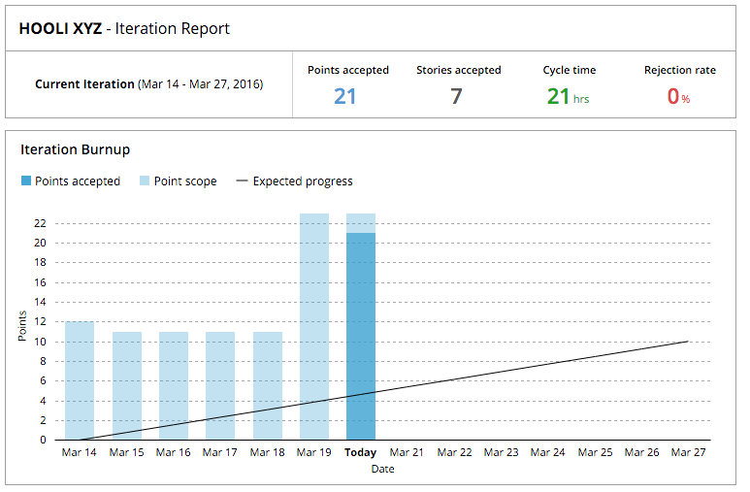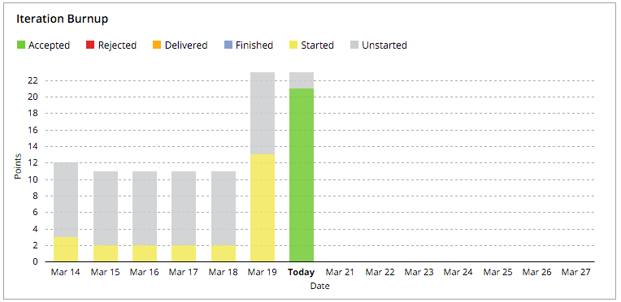

Figure 1: Iteration Burnup – Points and Stories

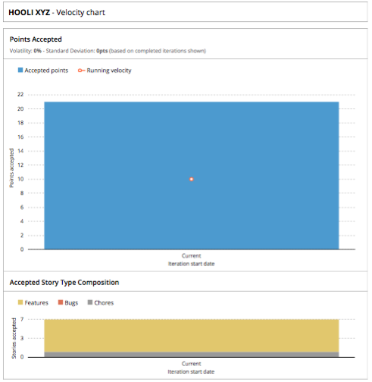

Figure 2: Velocity Chart

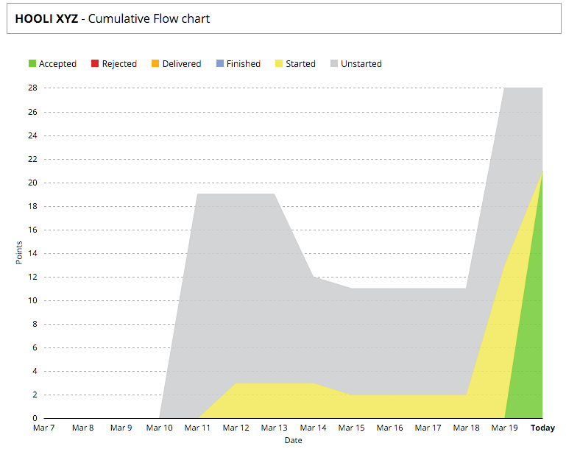

Figure 3: Cumulative Flow Chart

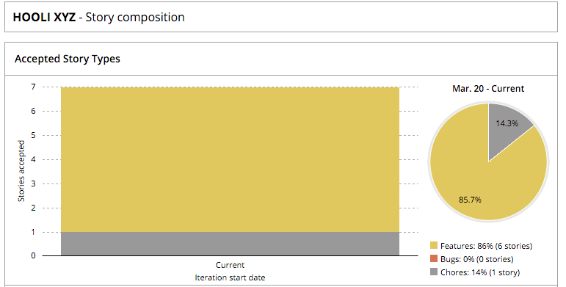

Figure 4: Story Composition

**4. Sprint Retrospective**

**Sprint Ratings**

* Communication: ???/10
* Performance: ???/10
* Work Ethic: ???/10

**What went well?**

Several factors worked well within our group for Sprint 1. The team’s motivation and work ethic was very high with a strong desire to get started on the project. Team meetings were easy to schedule due to team members availability. This was also helped by the strong communication between all team members. Team members worked on user stories in pairs and we found this to be very productive. The high completion rate of user stories within the iteration was also notable. Learning how to utilize the tools we are used for the platform has been a steep learning curve. Nevertheless team members have adapted well to this setback.

**We want to keep doing:**

The team will continue to hold weekly meetings on Mondays, subject to the availability of team members. Stories will also continue to be worked on in pairs to keep efficiency as high as possible. The team’s performance in relation to stories completed was strong in this iteration and we want to keep this level of performance and quality throughout the remaining sprints.

**What did not go well?**

The majority of the Project Design and SCRUM methodology concepts undertaken within the sprint are new to everybody in the team. It has taken some time to adapt to these techniques and thus, the team’s progress was somewhat slower than expected. Preparation for the start of the sprint was poor and this resulted in the first week being under-utilized. This added further time constraints given the short length of the sprint in comparison to the next two upcoming sprints. This put additional pressure onto the team to finish the user stories. Delegation of tasks could also have been improved, with some team members being under-utilized, with others having a larger workload.

**We want to start:**

In addition to the weekly progress meetings, we may also start holding small SCRUM meetings throughout the week to further clarify our progress. For the next sprint, we will improve our performance by aiming to hold at least 3 full meetings. We also aim to complete an extra 4 user stories within the next sprint.

**Appendix B: Screenshots of Functionality**